Assignment By: Ms. Shweta Mishra

1. Test Scenarios Tested:
- Create Student by giving required info only. Student is added and appears on CaseLoad search page.
- Create Student by giving all information except for First and Last name. Student information is not saved as create button remain disabled.
- Create Student by giving all information. Student is created and appears on CaseLoad search page
- Search the newly created student from search box and apply various filters. Student is found in search.
- Edit the newly added Student. Student is edited successfully.
- Edit an existing Student. Student is edited successfully.
- Delete new/existing student. Student is deleted successfully.
- Add Goals for the new/existing student. Goals are created
- Add template and share in library. Template is created and shared successfully.
- Add Interest. Interest is added successfully

2. Detailed Test Cases:
Field | Description
Test Case ID | TC-01
Title | Create a student record.
Preconditions | Log in to staging.ablespace.io
Test Data | First Name= Demo; Last Name = Student 4; Service Time =20; School Name = Demo school4; Grade= 1st; DOB=02/09/2021; Teacher = Test teacher; RoomNo. = 121; IEP Due Date =11/01/2026; Eval due date =11/30/26; Case manager = Test Case Manager; Eligibility= BTech
Steps | - Click the ABleSpace menu -> Caseload on left menu.  - Click ‘Add Student ‘ button on Top Right side.  - Click ‘Add Manually’.  - Verify Expected Result 1.  - Enter following info in ‘Add Student’ form:  First Name= Demo ; Last Name = Student 4 ; Service Time =20 ; School Name = Demo school4; Grade= 1st; DOB=02/09/2021; Teacher = Test teacher; RoomNo. = 121; IEP Due Date =11/01/2026 ;Eval due date =11/30/26; Case manager = Test Case Manager ; Eligibility= BTech  - Click Create
Expected Result | 1 . ‘Add Student’ form should open.  2. Student info should be saved and appear in CaseLoad grid pane.
Actual Result | 1. ‘Add Student form’ opens.  2. Student info is saved and Visible in CaseLoad Grid pane
Status | Pass

Field | Description
Test Case ID | TC-02
Title | Create a student record without Required Fields
Preconditions | Log in to staging.ablespace.io
Test Data | Service Time =20 ; School Name = Demo school4; Grade= 1st; DOB=02/09/2021; Teacher = Test teacher; RoomNo. = 121; IEP date =11/01/2026 ; Eval due date =11/30/26; Case manager = Test Case Manager; Eligibility= BTech
Steps | - Click the AbleSpace menu -> Caseload on left menu.  - Click ‘Add Student ‘ button on Top Right side.  - Click ‘Add Manually’.  - Enter all info ( given in ‘Test Data’ above) except First Name and Last Name in ‘Add Student’ form .
Expected Result | 1.’ Create’ button should be disabled.  2. Record should not be saved
Actual Result | 1. ‘Create’ button is disabled.  2. Record is not saved
Status | Pass

Field | Description
Test Case ID | TC-03
Title | Caption to enter required fields (First Name and Last Name) should be displayed by default on ‘Add Student’ Form .
Preconditions | Log in to staging.ablespace.io
Test Data | Service Time =20 ; School Name = Demo school4; Grade= 1st; DOB=02/09/2021; Teacher = Test teacher; RoomNo. = 121; IEP date =11/01/2026 ; Eval due date =11/30/26; Case manager = Test Case Manager; Eligibility= BTech
Steps | - Click the AbleSpace menu -> Caseload on left menu.  - Click ‘Add Student ‘ button on Top Right side.  - Click ‘Add Manually’.  - ‘Add Student' Form should open .  - Verify Expected Result 1.  - Enter all information mentioned in Test Data in Student form, leaving First Name and Last name fields blank.  - Verify Expected Result 2.
Expected Result | - By Default focus should be on First Name.  - Caption (First name/Last Name is required) should be visible on when focus is lost from First Name and Last Name textboxes
Actual Result | By Default , focus is not on First Name.  Caption (First name/Last Name is required) is not visible.
Status | Fail

Field | Description
Test Case ID | TC-04
Title | Appropriate Word limit for all fields in ‘Add Student’ form
Preconditions | Log in to staging.ablespace.io
Test Data | Test Data TestData TestData TestData TestData TestData TestData TestData TestData TestData TestData TestData TestData TestData TestData TestData TestData TestData TestData TestData TestData TestData TestData TestData TestData TestData TestData TestData TestData TestData TestData TestData TestData TestData TestData TestData TestData TestData TestData TestData TestData TestData TestData TestData TestData TestData TestData TestData TestData TestData TestData TestData TestData TestData TestData TestData TestData TestData TestData TestData TestData TestData TestData TestData TestData TestData TestData TestData TestData TestData TestData TestData TestData TestData TestData TestData TestData TestData TestData TestData TestData TestData TestData TestData TestData TestData TestData TestData TestData TestData TestData TestData TestData TestData TestData TestData TestData TestData TestData TestData TestData TestData TestData TestData TestData TestData TestData TestData TestData  (115 words)
Steps | - Open ‘Add Student’ form  - Enter string mentioned in Test Data for following fields  First Name; Last Name ; Service Type; School Name ; Teacher; RoomNo; Case manager; Eligibility
Expected Result | Users should not be able to enter more than 50 words in these fields
Actual Result | Users is able to enter more than 500 words in these fields .
Status | Fail

Field | Description
Test Case ID | TC-05
Title | Discard unsaved changes on create a student record form.
Preconditions | Log in to staging.ablespace.io
Test Data | First Name= Demo ; Last Name = Student 4 ; Service Time =20 ; School Name = Demo school4; Grade= 1st; DOB=02/09/2021; Teacher = Test teacher; RoomNo. = 121; IEP Due Date =11/01/2026 ;Eval due date =11/30/26; Case manager = Test Case Manager ; Eligibility= BTech
Steps | - Click the ABleSpace menu -> Caseload on left menu.  - Click ‘Add Student ‘ button on Top Right side.  - Click ‘Add Manually’.  - Enter student info given above in TestData  - Click ‘X’ on the top right corner of form.  - Verify Expected Result1.  - Click Cancel  - Verify Expected Result2.  - Repeat Step 5 and click Discard button.  - Verify Expected Result 3.
Expected Result | - Message should appear with below info  Title: Discard Unsaved Changes?  Message: Are you sure you want to discard unsaved changes?  Cancel and Discard button.  - Message Should Disappear.  - Changes should be not saved and message box should disappear.
Actual Result | 1. Correct Message appears .  2. Message Disappeared  3. Changes should be not saved and message box disappeared
Status | Pass

Field | Description
Test Case ID | TC-06
Title | Search a Student
Preconditions | Logged in to staging.ablespace.io
Test Data | Search Student = Demo Student4
Steps | - Click the ABleSpace menu -> Caseload on left menu.  - Enter ‘Demo Student4’ in ‘Search student’ text Box.
Expected Result | ‘Demo Student4 ‘ Record should appear
Actual Result | ‘Demo Student4 ‘ is found
Status | Pass

Field | Description
Test Case ID | TC-07
Title | Edit Student record
Preconditions | Logged in to staging.ablespace.io
Test Data | Search Student = Demo Student4  FirstName = Demo1; Last name =Student5; School Name = Abc School; Grade = Preschool; DOB =01/19/2026; Teacher Name =Catherine; IEP Due Date =11/03/2026 ; Eval Due Date= 11/21/2026 ; Case Manager = Manager1; Eligibility= BA
Steps | - Click the ABleSpace menu -> Caseload on left menu.  - Enter ‘Demo Student4’ in ‘Search student’ text Box on right window pane.  - Click on ’ Demo Student4’  - Click on three vertical dots next to ‘View Student’ button.  - ‘Edit Student’ form should appear.  - Make following Changes” on ‘Edit Student form’:  FirstName = Demo1; Last name =Student5;  School Name = ‘Abc School’; Grade = Preschool;  DOB =01/19/2026;  Teacher Name =Catherine;  IEP Due Date =11/03/2026  Eval Due Date= 11/21/2026  Case Manager = Manager1; Eligibility= BA  - Click Update
Expected Result | Student record should be updated .
Actual Result | Record is Saved successfully with a notification.
Status | Pass

4. Bug reporting

Field | Description
Bug ID | BUG-01
Title | Delete button is disabled
Severity | Low
Priority | High
Environment | URL and date tested
Browser / Device | Chrome 129 on Windows 11
Reproducibility | Always
Steps to Reproduce | - Click CaseLoad on left menu  - Search for a student to delete  - Select the student.  - Under Profile Tab , click on 3 vertical dots next to view data and select delete.  - On Delete Student permanently message , enter ‘ Confirm ‘. Make sure there are few spaces (before /after or both ) with ‘ Confirm ‘ text .
Expected Result | Delete button should be enabled ( ‘ Confirm ‘ should be trimmed by the system.)
Actual Result | Delete button is disabled.
Evidence | 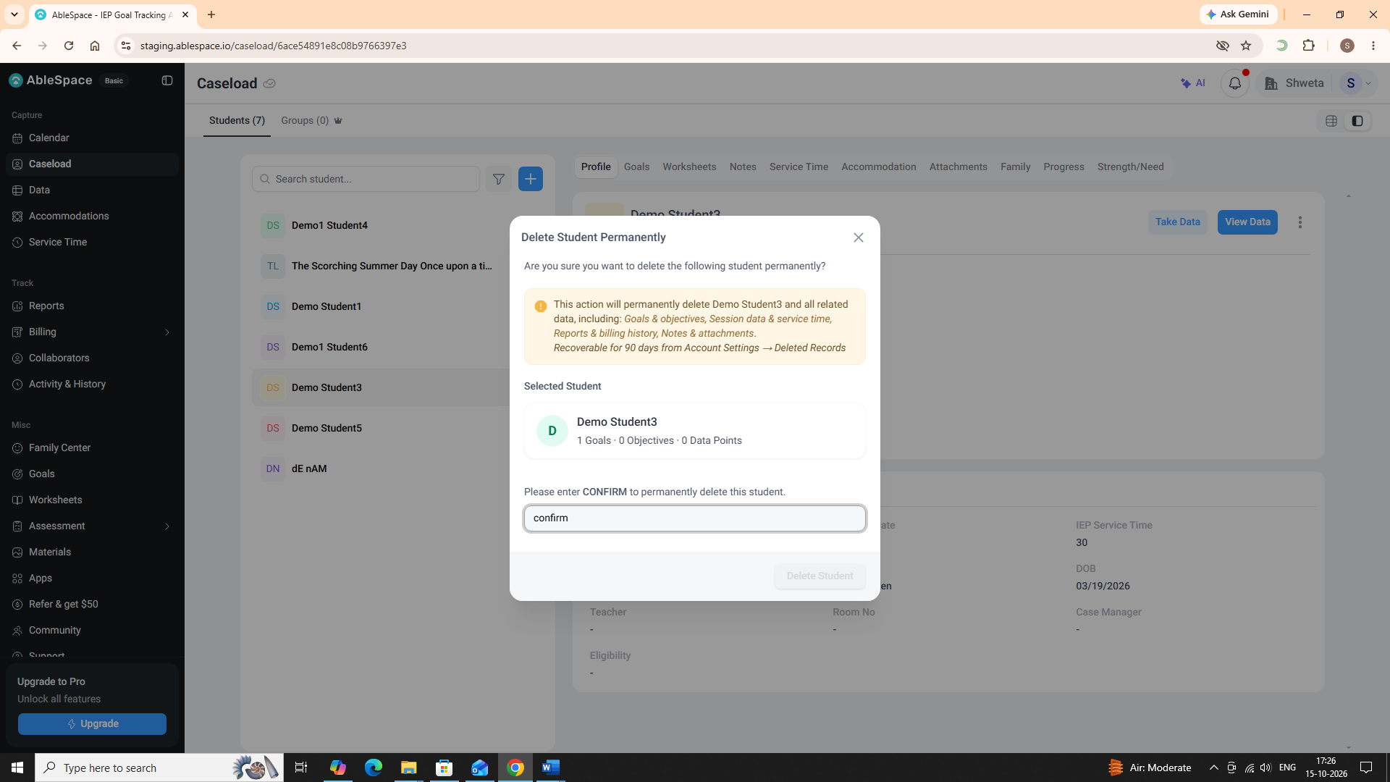

Field | Description
Bug ID | BUG-02
Title | Crop Image not working
Severity | Low
Priority | High
Environment | URL and date tested
Browser / Device | Chrome 129 on Windows 11
Reproducibility | Always
Steps to Reproduce | - Open ‘Add Student’ form  - Click Upload Student picture.  - Browse and select a picture  - Click open to open the picture selected in step 3  - Click Crop Image on top left corner.
Expected Result | User should be able to crop the picture using Crop Image
Actual Result | Crop Image does nothing. This is not functional.
Evidence | 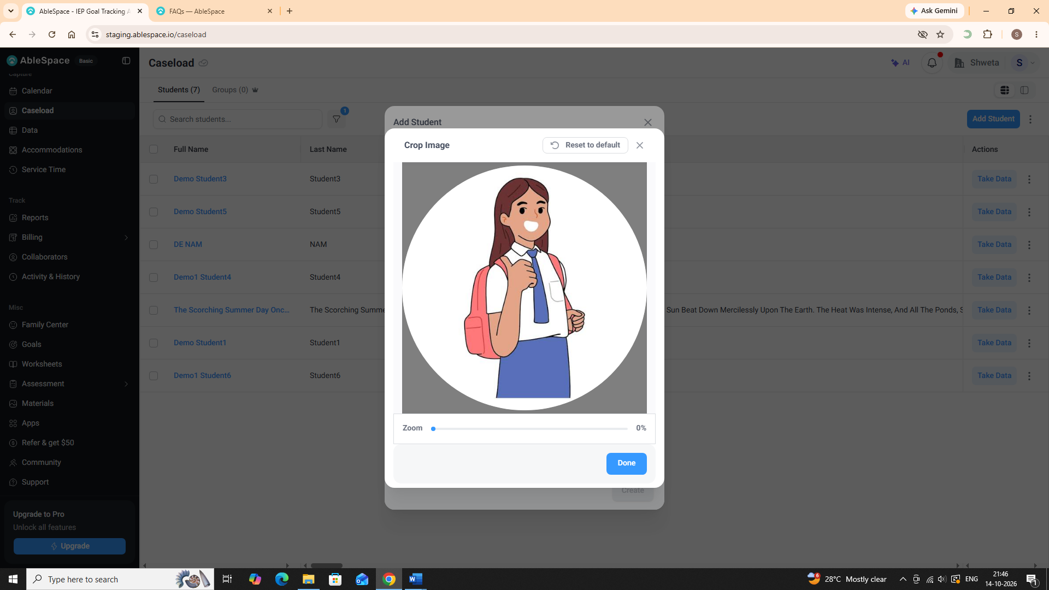

Field | Description
Bug ID | BUG-03
Title | No Word Limit in text fields on “Add Student” Form
Severity | Low
Priority | Medium
Environment | URL and date tested
Browser / Device | Chrome 129 on Windows 11
Reproducibility | Always
Steps to Reproduce | - Open ‘Add Student’ form  - Enter a string with 500 or more letters for following fields  First Name; Last Name ; Service Type; School Name ; Teacher; RoomNo; Case manager; Eligibility
Expected Result | Users should not be able to enter more than 50 words (or not such long strings) in these fields
Actual Result | Users is able to enter more than 500 words in these fields .
Evidence | 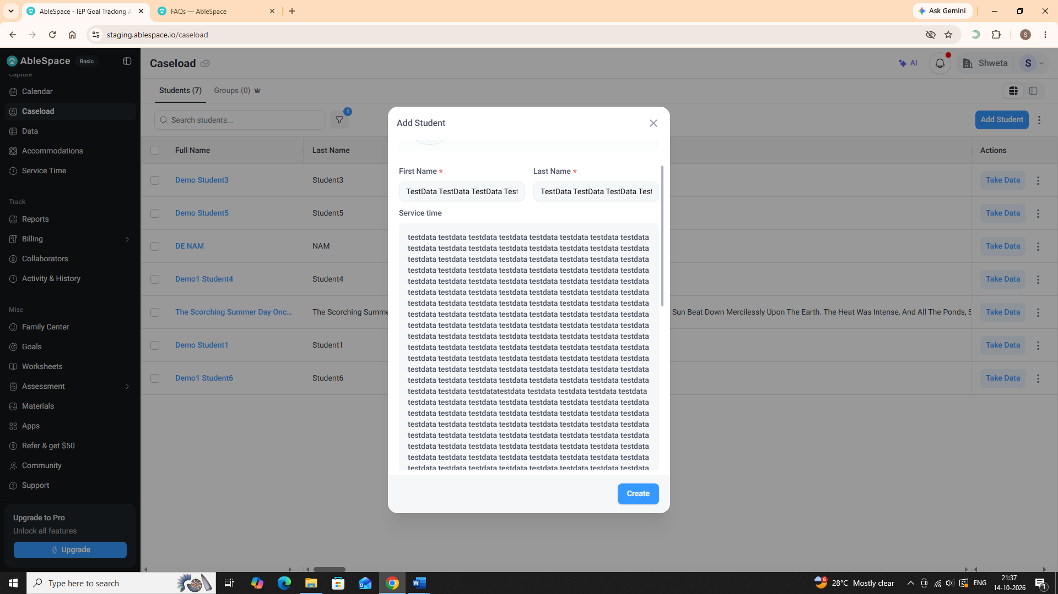

Other Issues:
- On student form, there should be validation that IEP Due date should be less or equal to Eval Due date.
- On Add /Edit student form, Name Fields should have validation /check to avoid special characters in Name Field.
- On Add /Edit student form , there should be some reasonable character limit for input fields.
- In search student, if records are sorted in descending order(latest appears first) for date (IEP DueDate /Eval Due Date ).. blank dates should appear last .
- Tab navigation is not properly working for Add /Edit student form
- On Add/Edit student form , when form opens, focus should be on First name
- Calendar once expands , does not collapse back when user clicks on calendar on left menu.
5. Cross-browser and responsive testing

Area / Feature | Chrome | Edge | Mobile | Notes
Signup and login | Pass | Pass | Pass
Main workflow | Pass | Pass | Pass
Forms | Pass | Pass | Pass
Navigation | Not Done | Not Done | Not Done

6. Test summary
- Testing performed: Tested Add Student ->Search student -> Edit student -> Delete Student and on which Chrome, Edge and Android.
- Issues found: 3 bugs found, and BUG-01should be fixed first and it is really frustrating for the user if S/he is not able to delete student even after confirming.
- Areas not tested: Links other than CaseLoad are not tested because of unavailability of Functional spec and time constraint. Would love to test further if Functional Spec is provided.
- What I would test next: Remaining features of Caseload as it is the most important feature of the application.

